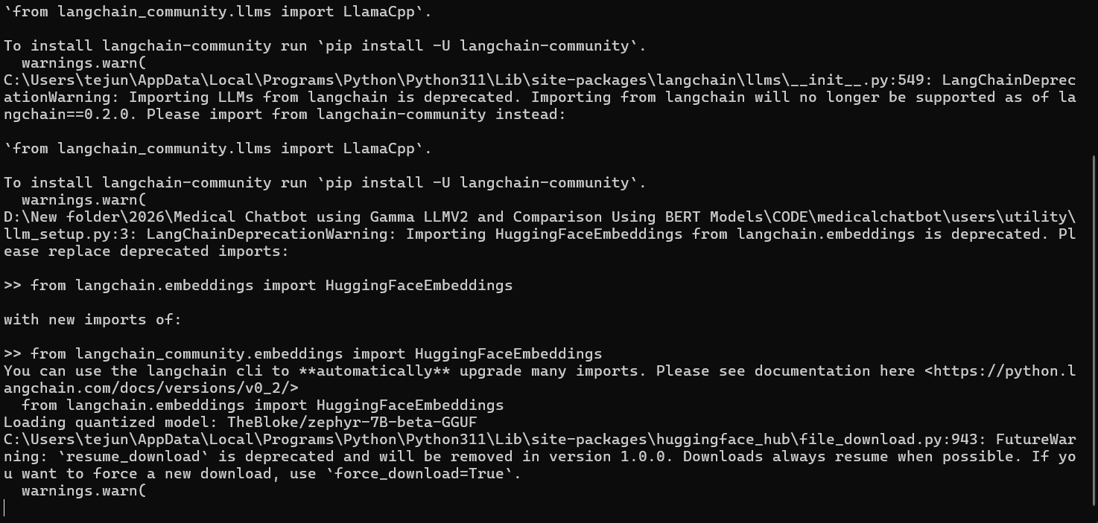

While running the server will get this warning message don’t worry it a warning message only not the error this means it will give you the server

